**Naive Bayes**

Naïve Bayes algorithm is a supervised learning algorithm.It is a probabilistic classifier, which means it predicts on the basis of the probability of an object.examples of Naïve Bayes Algorithm are **spam filtration, Sentimental analysis, and classifying articles.**

**Why is it called Naïve Bayes?**

**Naïve:**It is called Naïve because it assumes that the occurrence of a certain feature is independent of the occurrence of other features. Such as if the fruit is identified on the bases of color, shape, and taste, then red, spherical, and sweet fruit is recognized as an apple. Hence each feature individually contributes to identify that it is an apple without depending on each other.

**Bayes :It is called Bayes because it depends on the principle of [Bayes' Theorem](https://www.javatpoint.com/bayes-theorem-in-artifical-intelligence" \t "https://www.javatpoint.com/_blank).**

****Bayes' Theorem:** is used to determine the probability of a hypothesis with prior knowledge. It depends on the conditional probability.**

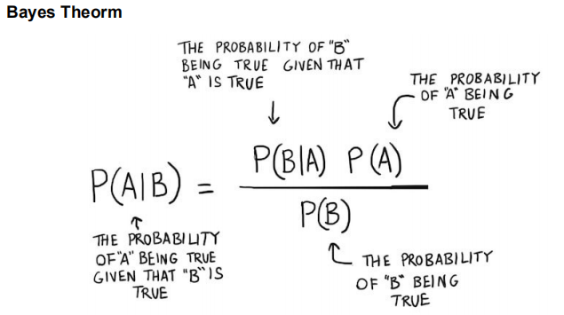

* ****P(A|B) is Posterior probability:** Is the probability of hypothesis A given the data B.**
* ****P(B|A) is Likelihood probability**:is the probability of data B given that the hypothesis A was true.**
* ****P(A) is Prior Probability**: is the probability of hypothesis A being true (regardless of the data).**
* ****P(B) is Marginal Probability:** is the probability of the data (regardless of the hypothesis).**

****P(A|B) or P(B|A) are conditional probabilities P(B|A) = P(A and B)/P(A)****

****Example :****

****Question: From a standard deck of playing cards, a single card is drawn. The probability that the card is king is 4/52, then calculate posterior probability P(King|Face), which means the drawn face card is a king card.****

****Solution:****

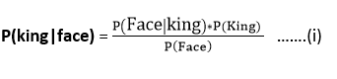

P(king): probability that the card is King= 4/52= 1/13

P(face): probability that a card is a face card= 3/13

P(Face|King): probability of face card when we assume it is a king = 1

Putting all values in equation (i) we will get:

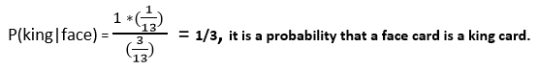

**Types of Naïve Bayes Model:**

**Types of Naive Bayes Classifier:**

**1. Multinomial Naive Bayes**

**2. Bernoulli Naive Bayes**

**3. Gaussian Naive Bayes**

a. **Multinomial Naive Bayes:** This is mostly used for document classification problem, i.e whether a

document belongs to the category of sports, politics, technology etc. The features/predictors used by the

classifier are the frequency of the words present in the document.

b. **Bernoulli Naive Bayes:** This is similar to the multinomial naive bayes but the predictors are boolean

variables. The parameters that we use to predict the class variable take up only values yes or no, for

example if a word occurs in the text or not.

c. **Gaussian Naive Bayes :** When the predictors take up a continuous value and are not discrete, we

assume that these values are sampled from a gaussian distribution.

**Applications of Naive Bayes Algorithm :**

* Naive Bayes is widely used for text classification
* Another example of Text Classification where Naive Bayes is mostly used is Spam Filtering in Emails
* Other Examples include Sentiment Analysis , Spam filtering ,Recommender Systems etc .
* It is used for Credit Scoring.
* It is used in medical data classification.
* It can be used in real-time predictions because Naïve Bayes Classifier is an eager learner.

**Advantages of Naïve Bayes Classifier:**

* Naïve Bayes is one of the fast and easy ML algorithms to predict a class of datasets.
* It can be used for Binary as well as Multi-class Classifications.
* It performs well in Multi-class predictions as compared to the other Algorithms.
* It is the most popular choice for text classification problems.

**Disadvantages of Naïve Bayes Classifier:**

* Naive Bayes assumes that all features are independent or unrelated, so it cannot learn the relationship between features.